Walnut Tree Avenue, Rendlesham, IP12 2GG Charity no. 1125733
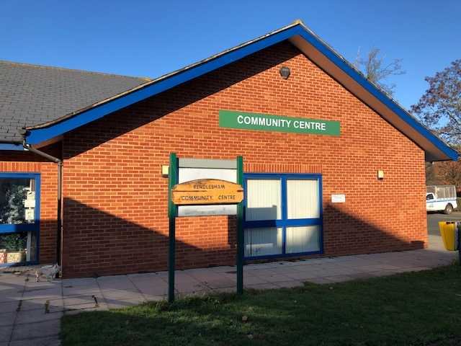
Excellent Facilities for Receptions, Meetings,
Group Activities and Private Functions
Commercial bookings: RCCMC Trustees are bound to ensure that the Community Centre is administered in accordance with the Trust Deed; commercial bookings will only be accepted when there is no demand for a room by village residents or organisations.
The Community Centre is available for hire 7 days a week from
8:00 a.m. – 11:00 p.m. dependent on prior bookings
 | Size | Standing/seated rows | Seated at tables | Fee
Room 1 | 12 x 11 m | 120 | 95 | £36
Room 13 | 8 x 4 m | 32 | 25 | £15
Room 16 | 5 x 9.5 m | 48 | 38 | £20
All rates above are for a minimum 2 hour hire period, 30 minutes preparation and 30 minutes clear up time is additionally permitted (N.B. no reduction is available for shorter bookings)
The Community Centre is fully accessible to wheelchair users
Please complete the Booking Enquiry form overleaf or contact us: 01394 460005
07599 998974 rendlesham.commcentre@gmail.com

Rendlesham Community Centre Booking Enquiry
This form can be handed in, posted or emailed to the Community Centre: rendlesham.commcentre@gmail.com You will be contacted by the Booking Administrator to confirm room availability. Your details will be safely stored in connection with this booking only and will not be shared with anyone else.
Room required ________
Date(s) __________________ Time_____________
I would like seating in rows/tables and chairs/floor space (delete as appropriate) for approximately ________ people
The enquiry is for a Single/Regular Booking
I do/do not require the use of the kitchen
Name _____________________________ (please print)
Phone _______________ Mobile _________________
Email _________________________________________
Address _______________________________________
_____________________________________ (include postcode)
Organisation ______________________________ (where applicable)
Your booking will be confirmed and you will be sent the Standard Terms of Hire, two copies of the Contract of Hire and the Health and Safety Compliance Sheet by email unless you tell us that you would like paper copies. Please arrange a mutually convenient time to meet with the Bookings Administrator to view the Community Centre. Your contact details will only be used in connection with this booking and will not be shared with anyone else.
One copy of the Contract of Hire should be returned to the Community Centre.
N.B. You must be 18 or over to book a room at Rendlesham Community Centre. The Trustees do not permit 18th or 21st Birthday Parties to be held at the Community Centre.
For Office Use Only Booking number:

